1. **Sequence Diagram for the Speech-to-Text Converter Project**

A sequence diagram represents the interaction between objects in a sequential order. Below are detailed sequence diagrams for various user stories in the project.

**1. Sequence Diagram for "Start Recording" (User Story 1)**

1. **User clicks the "Start Recording" button:**
   * UserInterface calls AudioRecorder.start()
   * AudioRecorder starts recording audio and updates is_recording to true
2. **Sequence Diagram:**

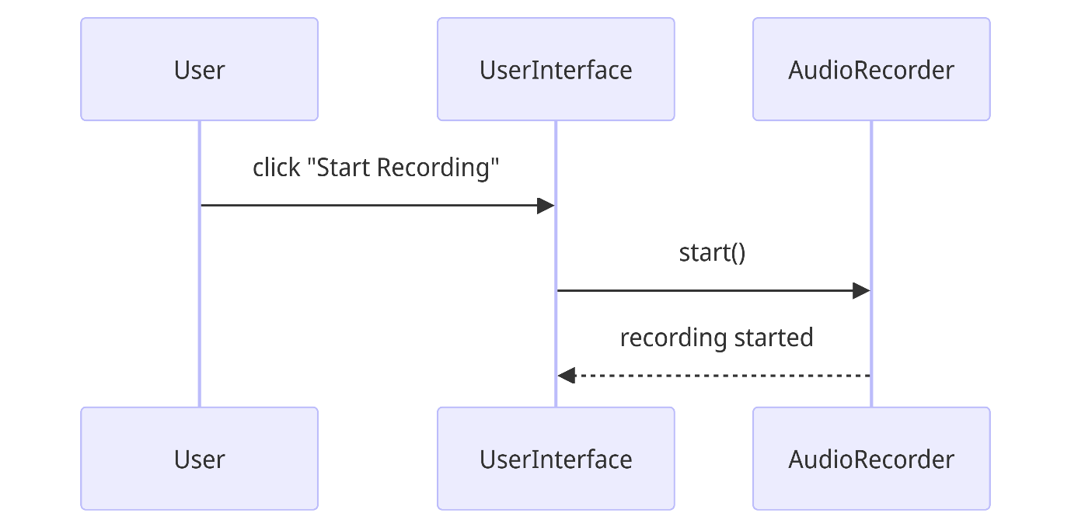

**2. Sequence Diagram for "Stop Recording and Transcribe" (User Story 2)**

1. **User clicks the "Stop Recording" button:**
   * UserInterface calls AudioRecorder.stop()
   * AudioRecorder stops recording audio and updates is_recording to false
   * AudioRecorder calls AudioRecorder.save_audio()
2. **Transcribe the recorded audio:**
   * UserInterface calls TranscriptionService.transcribe_audio(audio_file_path)
   * TranscriptionService sends the audio file to SpeechRecognitionAPI
   * SpeechRecognitionAPI returns the transcription text
   * TranscriptionService returns the transcription text to UserInterface
   * UserInterface displays the transcription text
3. **Sequence Diagram:**

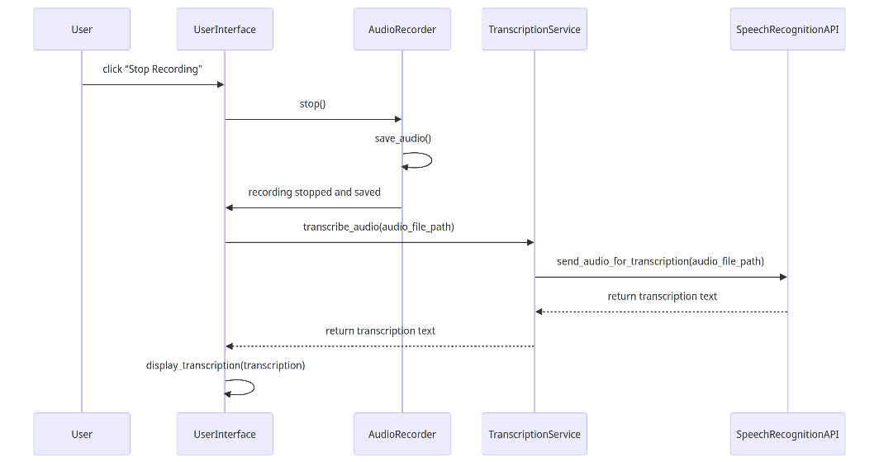

**3. Sequence Diagram for "Real-time Transcription" (User Story 3)**

1. **User speaks into the microphone:**
   * UserInterface captures audio in real-time
   * UserInterface sends audio chunks to TranscriptionService periodically
2. **Transcribe audio chunks in real-time:**
   * TranscriptionService sends audio chunks to SpeechRecognitionAPI
   * SpeechRecognitionAPI returns partial transcription text
   * TranscriptionService returns partial transcription text to UserInterface
   * UserInterface updates the displayed transcription text in real-time
3. **Sequence Diagram:**

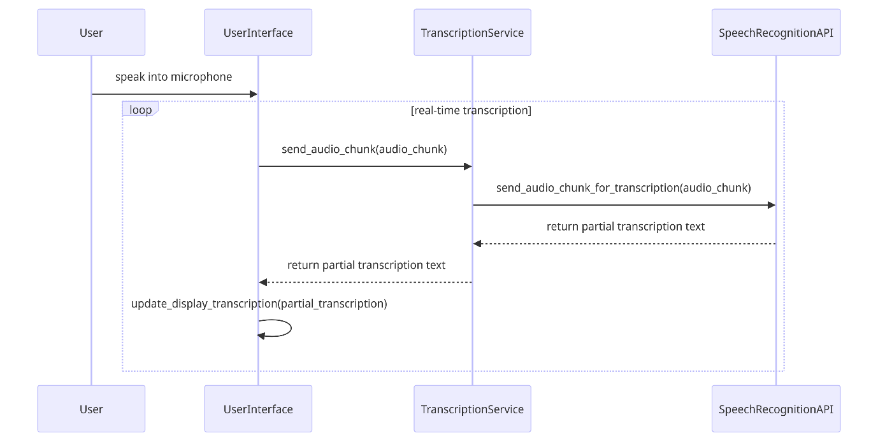

**4. Sequence Diagram for "Multi-language Support" (User Story 5)**

1. **User selects a language for transcription:**
   * UserInterface updates the current language in Settings
2. **Transcribe audio in selected language:**
   * UserInterface calls TranscriptionService.transcribe_audio(audio_file_path, language)
   * TranscriptionService sets the language model in LanguageModel
   * TranscriptionService sends the audio file to SpeechRecognitionAPI with the language setting
   * SpeechRecognitionAPI returns the transcription text in the selected language
   * TranscriptionService returns the transcription text to UserInterface
   * UserInterface displays the transcription text
3. **Sequence Diagram:**

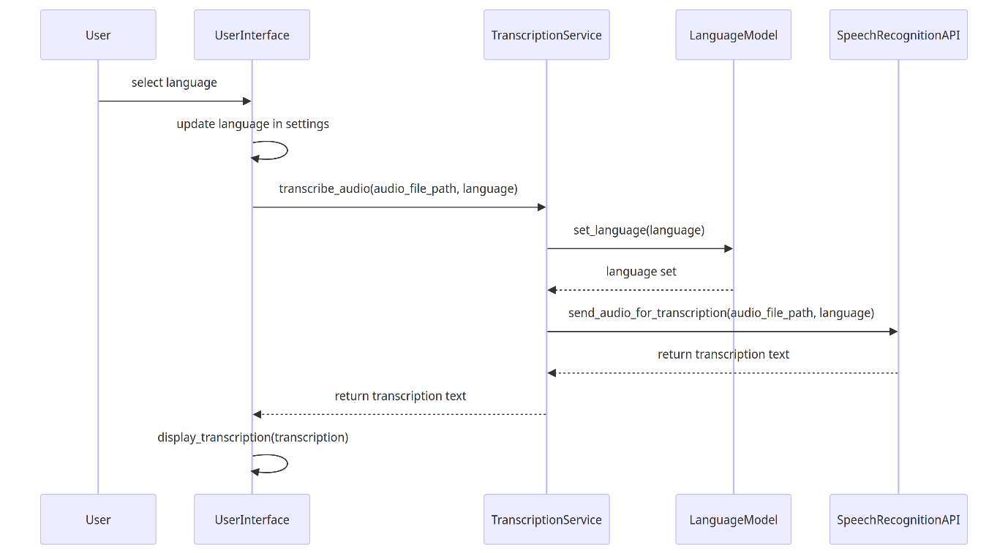

**5. Sequence Diagram for "Save Transcription and Secure Data Handling" (User Story 11)**

1. **User saves the transcription:**
   * UserInterface calls DataManager.save_transcription(transcription, audio_file_path)
2. **Encrypt and store the transcription:**
   * DataManager calls SecurityService.encrypt_data(transcription)
   * SecurityService returns the encrypted transcription
   * DataManager saves the encrypted transcription to the database
3. **Sequence Diagram:**

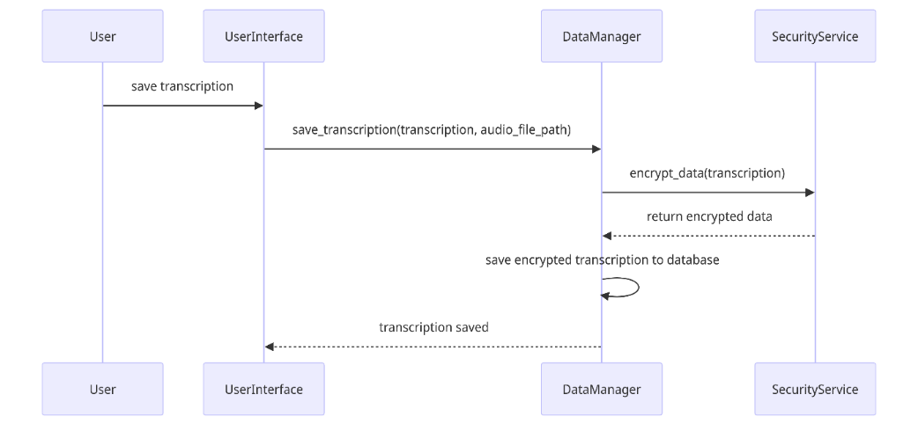

These sequence diagrams provide a clear view of the interactions between the different components of the system for various user stories, illustrating how the application processes user inputs and handles data.

